WICKLOW COUNTY COUNCIL

Community

Awards Scheme

2023

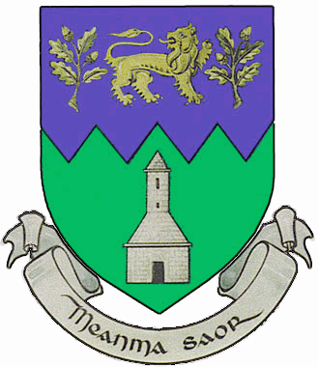

Community Awards 2023

Guidelines & Application Form

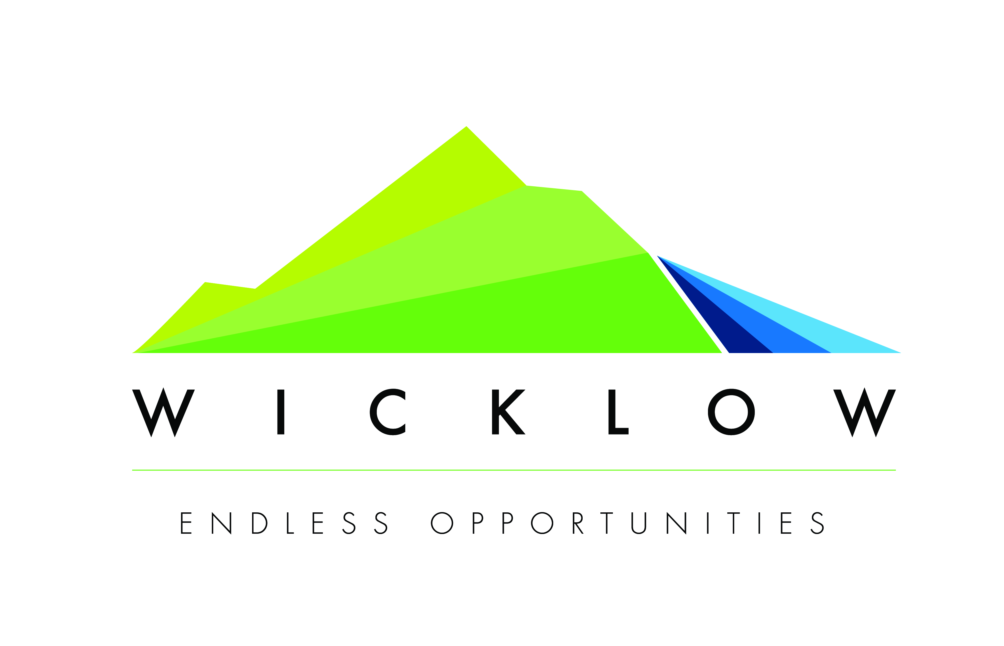

PLEASE READ THE DETAILS OF THE SCHEME PRIOR TO COMPLETING THE APPLICATION FORM.

Community Awards Scheme 2023

Ethos and focus of awards
The purpose of the Wicklow County Councils Community Award Scheme is to assist local community and voluntary groups, including sporting, arts and cultural organisations that would benefit from small scale or once-off funding to support the groups’ activities i.e. running costs or to develop a particular project. The Award Scheme gives the County Council the opportunity to recognise and value the voluntary contribution made by local groups in their own localities.

Applications will not be accepted from statutory bodies. Proposals from individuals will not qualify.

Aims of the Community Award Scheme
The aim of this Fund is to support community and voluntary groups in County Wicklow who wish to undertake projects that will:

- Carry out a service or activity that makes a contribution to the quality of life in their local community.
- Increase voluntary activity,
- Target the socially excluded and increase their opportunities and particularly those who target anti-racism and accessibility issues.
- Recognise the valuable contribution of community and voluntary organisations in Wicklow in some way.

The maximum grant available is €500 per organisation – one application only per organisation.

Social inclusion is a central theme of the Programme – Social Inclusion is about focusing on the needs of marginalised and disadvantaged groups such as people with disabilities, the unemployed/low income groups, travellers, homeless, lone parents, gay/lesbian/bi-sexual/transgender community, older people, children/young people, rurally isolated etc.

Appraisal and decision process
A small appraisal committee including representation from the Municipal Districts will consider all applications made under the Community Awards Scheme.

Key considerations in assessing applications will include:

- Group contributes to the general wellbeing and quality of life of the local community
- The strength of the application – it is very important to supply all
information requested on the form
- Social inclusion and anti-racism projects
- Sports participation opportunities for disadvantaged
- The ability of the group to carry out the project
- The impact, scope and inclusiveness of the project.
- Sustainability
- Beneficial if the group adheres to the Governance Code
- Beneficial if your group is a member of the Public Participation Network (PPN)

When will grants be paid?
The grants will be paid out to successful applicants via Electronic Fund Transfer (EFT) to the receiving organisation’s bank account by the end of June 2023, subject to timely receipt of financial details.

Closing Date
The closing date for receipt of completed applications is 4.00 p.m. on Friday 24th February 2023. Late applications will not be considered.

Applications should be sent to Community Awards Scheme 2023, Community Cultural & Social Development, Wicklow County Council, County Buildings, Whitegates, Wicklow, A67 FW96 or scanned and emailed to ccsdadmin@wicklowcoco.ie to arrive before the deadline.

Application Process
Please do not submit multiple applications as only one application per organisation will be considered.

Application for a grant should be made by downloading the form on Wicklow County Council’s website www.wicklow.ie

Queries should be directed to Community, Cultural & Social Development. Tel. (0404) 20208 or email: ccsdadmin@wicklowcoco.ie

- In order to process your application it may be necessary for Wicklow County Council to collect personal data from you. Such information will be processed in line with the Local Authority’s privacy statement which is available to view on Wicklow.ie.

PLEASE TICK TO CONFIRM THAT THE FOLLOWING DOCUMENTS ARE AVAILABLE, IF REQUESTED:

Copy of current Bank, Credit Union or An Post statement.
McKenna

Copy of group constitution.

PLEASE NOTE A COPY OF A CURRENT BANK, CREDIT UNION OR AN POST STATEMENT WILL NEED TO BE SUBMITTED IF YOUR APPLICATION IS SUCCESSFUL. FAILURE TO SUBMIT SAME WILL RESULT IN YOUR GRANT FUNDING BEING WITHDRAWN.

WICKLOW COUNTY COUNCIL
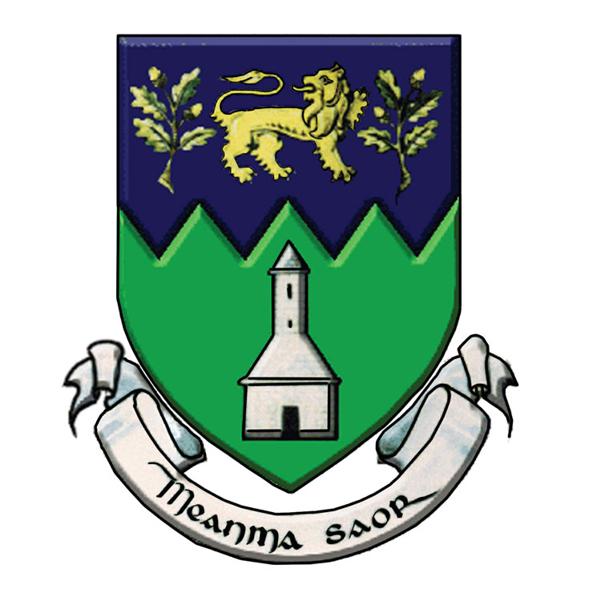
Community awards 2023
APPLICATION FORM

Name of Community/Voluntary Group

_
Tax Reference Number or Charitable Status (CHY) Number: (if Applicable)

Contact Details
Name
Address

Eircode
Position held in group
Daytime Telephone Number
Email Address
Municipal District in which group operates

Number of Voluntary Workers
Number of Paid Workers
How many members are there?
Is membership open?
Details of membership fees

What are the aims, objectives and ethos of your group?

What are the activities of your group?

What is the activity or action for which you are seeking a grant?

How will the activity or action be managed?

Why is there a need for this activity or action? Please provide support/proof of need or consultation carried out?

Who will benefit from this activity?

Governance Code: please tick the boxes to the following if the answer is yes:

Has your group signed up to the Governance Code?

Or is in the process of signing up?

Is your group a member of the Public Participation Network?

Name of your Group Bank/Post Office or Credit Union Account: (This is the name that appears on your statement).

Outline the estimated cost of the activity or action. €__________

Amount sought from Wicklow County Council. €__________

If the amount you are requesting is not the total cost of the proposed activity or action, please advise from where the balance of funds is coming

Have you applied for or received funding from any other source in the last year. If yes, please give details.

DECLARATION:

I declare that all the information given in this form is true and complete to the best of my knowledge and belief. I acknowledge that any funds awarded must be used for the purpose stated.

I also accept as a condition of the grant scheme:

- That it involves no commitment to any other grants from Wicklow County Council in the future.
- Wicklow County Council reserves the right to request further information, if required.
- Wicklow County Council will undertake to review the scheme from time to time and as a result may make any changes necessary without any prior notice and at the Council’s discretion.
- That Wicklow County Council hold no responsibility for the project and that the project must meet with all Planning and Health and Safety Regulations.
- To have the project monitored by Wicklow County Council or by its agents, to allow access to its premises and records, as necessary for that purpose.
- To provide details of the grant spent in the Evaluation Form provided by the 31st December, 2023.
- That grant allocation must be used for the project approved and grant monies unspent by the end of 2023 must be returned.

Signed: _________________________ Date: ____________________

Name (in block capitals): ___________________________

Position in Organisation:

Chairperson

Secretary

Other (please indicate position held) ____________________

Does your group wish to receive email notification from Wicklow County Council regarding future community funding schemes?

Yes No

Your contact details will not be shared or used for any other purpose, in line with Wicklow County Council’s privacy statement which is available at www.Wicklow.ie

